**[](http://www.calstatela.edu/centers/hipic)** **CIS5560 Term Project Tutorial**

Authors: Joey Tran; Garrett Tice; Brandon Ascencio; Kyle Alfonso; Michael Campos

Instructor: Jongwook Woo

Date: 12/7/2020

**Lab Tutorial**

Michael Campos ([mcampo61@caltstatela.edu](mailto:mcampo61@caltstatela.edu))

Garrett Tice ([gtice@calstatela.edu](mailto:gtice@calstatela.edu))

Joey Tran ([jtran66@calstatela.edu](mailto:jtran66@calstatela.edu))

Brandon Ascencio ([bascenc8@calstatela.edu](mailto:bascenc8@calstatela.edu))

Kyle Alfonso ([kalfons@caltstatela.edu](mailto:kalfons@caltstatela.edu))

12/7/2020

## **NYC 311 Service Request Data Analysis using Hive & Tablea**

## 

## **Objectives**

In this hands-on lab, you will learn how to:

* Download files into Apache Hadoop
* Create Hive tables to query data set
* Create queries to analyze the data
* Use Tableau to create visualization of analysis

## **Platform Spec**

* Oracle BDCE
* CPU Speed: 2.20GHz
* # of CPU cores: 12 OCPUs
* # of nodes: 3
* Total Memory Size: 180 GB
* Storage Size: 957 GB

### **Prerequisites**

* Tableau

Step 1: Downloading and Uploading Data Set

This step will be to download the provided data set for NYC 311 Service request into our Oracle server. From there we can upload it to the hadoop server for further analysis.

1. Open your computer’s command prompt or terminal and SSH into oracle server.

ssh [your_username]@129.150.64.74

1. Change directory to a folder that can handle large files. For this example we will be using /dev/shm directory since our home folder may not have enough storage space.

$ cd /dev/shm

1. Download the data set from amazon S3 and extract.

$ wget <https://s3-us-west-1.amazonaws.com/cis.group.project/311_Service_Requests.zip>

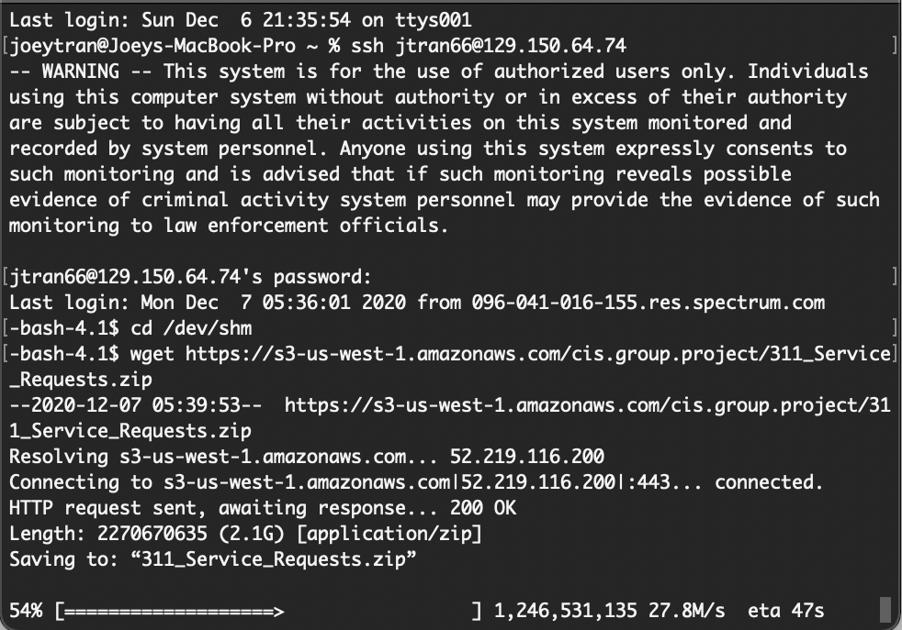

$ unzip 311_Service_Requests.zip

1. Create folders in hadoop for data set and upload.

$ hdfs dfs -mkdir Services

$ hdfs dfs -put 311_Service_Requests_from_2010_to_Present.csv Services

1. Change file permissions so that it can be used. Be sure to include the . at the end.

$ hdfs dfs -chmod -R o+w .

1. Check to see if files are inside the Services folder.

$ hdfs dfs -ls Services

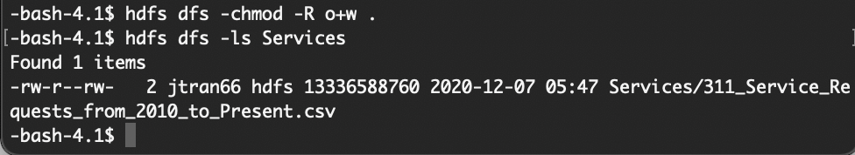

Step 2: Create Hive Tables to Query

In this step, we will create Hive tables from our uploaded data set.

1. Type beeline to open the Hive interface.

$ beeline

1. Run the following command to access the class database. There is no password so press enter when prompted.

!connect jdbc:hive2://bigdai-nov-bdcsce-1:2181,bigdai-nov-bdcsce-2:2181,bigdai-nov-bdcsce-3:2181/;serviceDiscoveryMode=zooKeeper;zooKeeperNamespace=hiveserver2?tez.queue.name=interactive bdcsce_admin

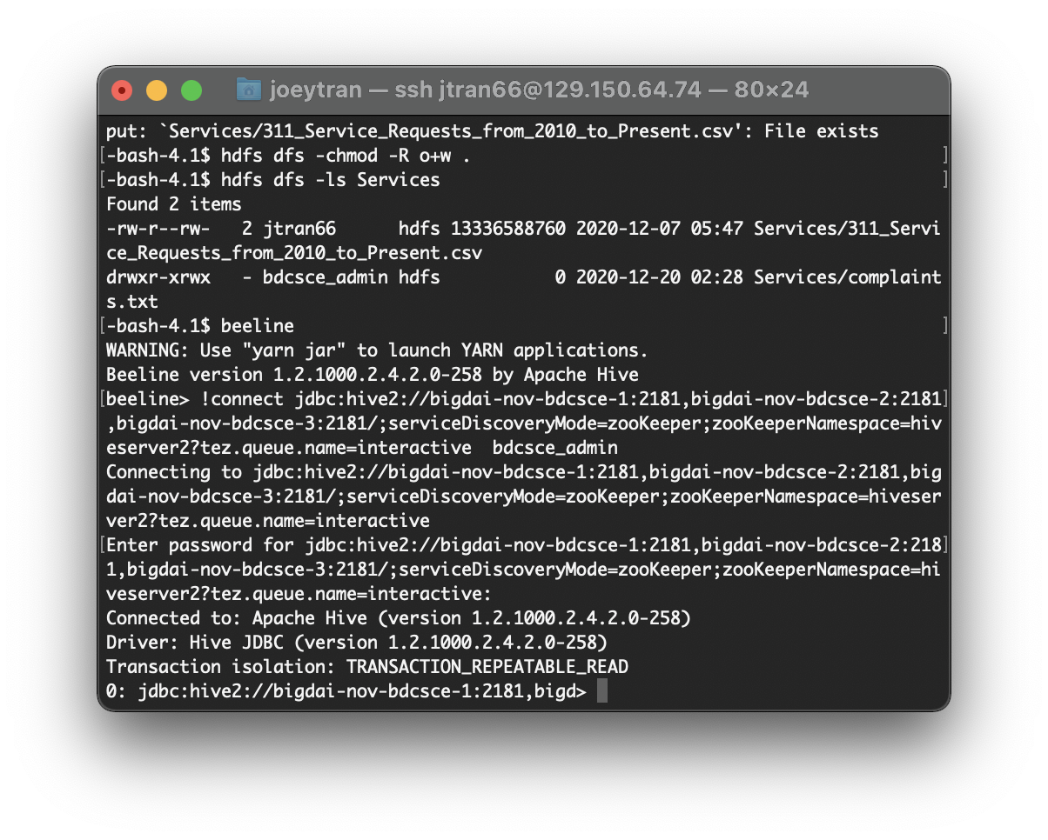

1. View and use your database.

beeline> show databases;

beeline> use [your_username];

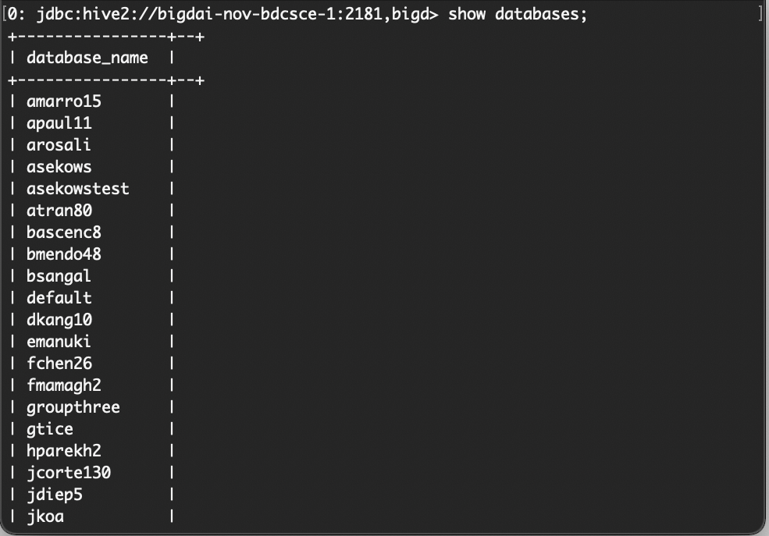

1. Copy and paste the following code to create a table name Service. The table created is from the CSV file using the Hive query. Be sure to change the highlighted red to your user name, so that it will save to the correct folder.

DROP TABLE IF EXISTS Services;

--create the building table on comma-separated building data

CREATE EXTERNAL TABLE IF NOT EXISTS Services(Unique_Key string,

Created_Date date,

Closed_Date date,

Agency string,

Agency_Name string,

Complaint_Type string,

Descriptor string,

Location_Type string,

Incident_Zip string,

Incident_Address string,

Street_Name string,

Cross_Street_1 string,

Cross_Street_2 string,

Intersection_Street_1 string,

Intersection_Street_2 string,

Address_Type string,

City string,

Landmark string,

Facility_Type string,

Status string,

Due_Date date,

Resolution_Description string,

Resolution_Action_Updated_Date date,

Community_Board string,

BBL string,

Borough string,

X_Coordinate_State_Plane int,

Y_Coordinate_State_Plane int,

Open_Data_Channel_Type string,

Park_Facility_Name string,

Park_Borough string,

Vehicle_Type string,

Taxi_Company_Borough string,

Taxi_Pick_Up_Location string,

Bridge_Highway_Name string,

Bridge_Highway_Direction string,

Road_Ramp string,

Bridge_Highway_Segment string,

Latitude double,

Longitude double,

Location string)

ROW FORMAT DELIMITED FIELDS TERMINATED BY ','

STORED AS TEXTFILE LOCATION '/user/bascenc8/Services'

TBLPROPERTIES ('skip.header.line.count'='1');

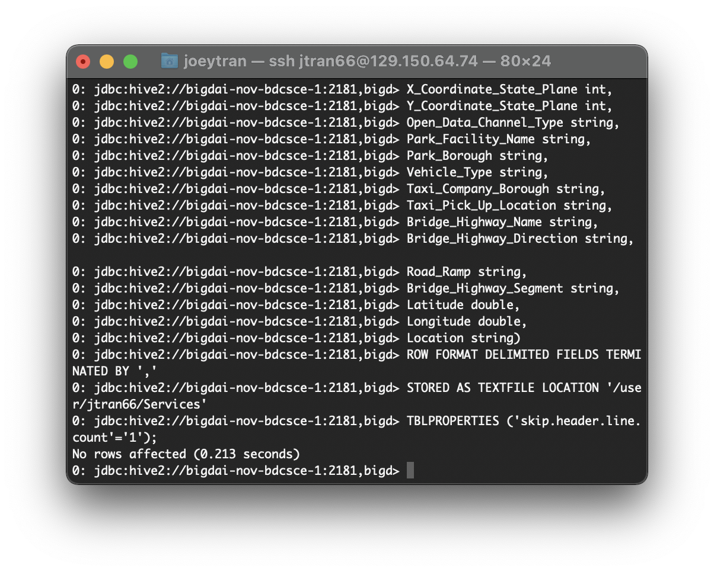

1. We will then create a complaints table using specific columns from the data set and overwrite with a new Hive query.

DROP TABLE IF EXISTS Complaints;

CREATE EXTERNAL TABLE IF NOT EXISTS Complaints(agency_name string, Complaint_type string, NumberofComplaints int)

ROW FORMAT DELIMITED FIELDS TERMINATED BY ', '

STORED AS TEXTFILE LOCATION '/user/bascenc8/Services/complaints.txt';

INSERT OVERWRITE TABLE Complaints

select agency_name, complaint_type, count(complaint_type) as NumberofComplaints from services group by agency_name, complaint_type having count(complaint_type) > 5 order by NumberofComplaints DESC;

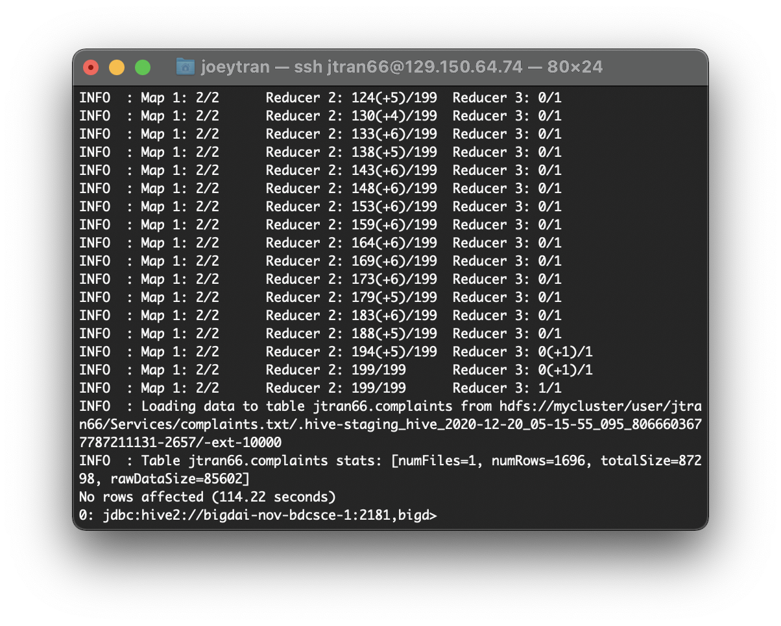

1. Check your database tables to see if you have the following tables: Services, Complaints

beeline> show tables;

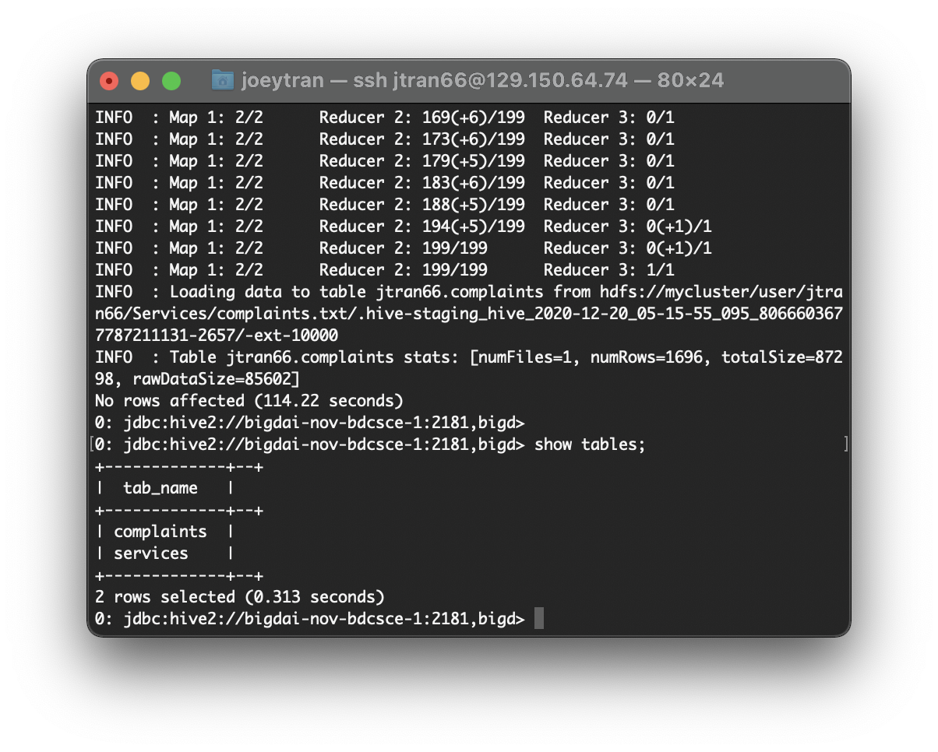

Step 3: Hive Query Analysis

This step will involve running queries from the created tables so that we can extrapolate useful information.

1. Let’s view some data from the newly created table within beeline. Enter the following code to display 10 rows of data from the created complaints table.

SELECT *

FROM complaints

LIMIT 10;

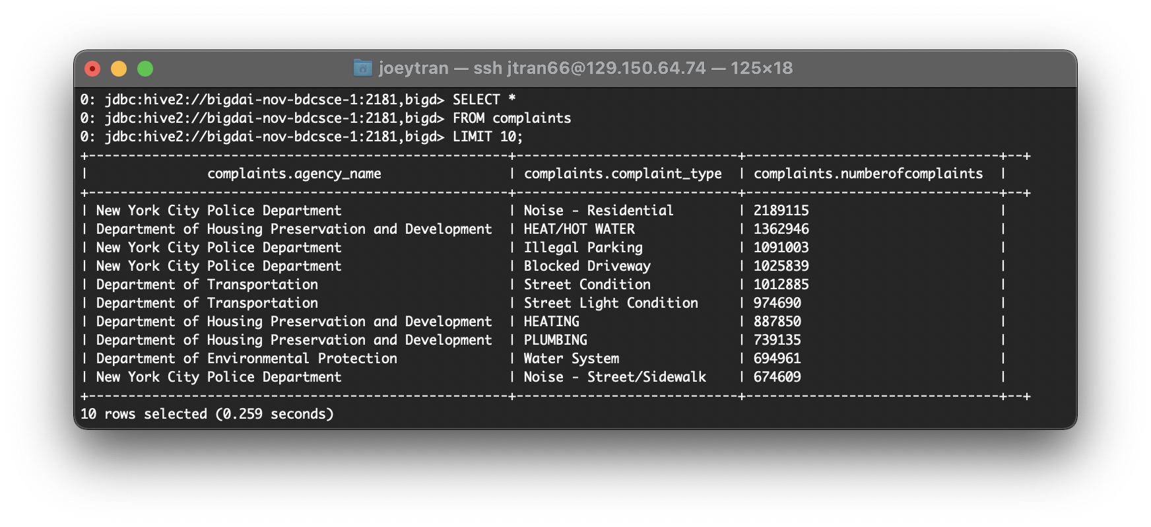

1. The following query will contain 10 rows of data from the complaints table that belong to the New York City Police Department.

SELECT *

FROM complaints

WHERE agency_name

LIKE 'New York City Police Department'

LIMIT 10;

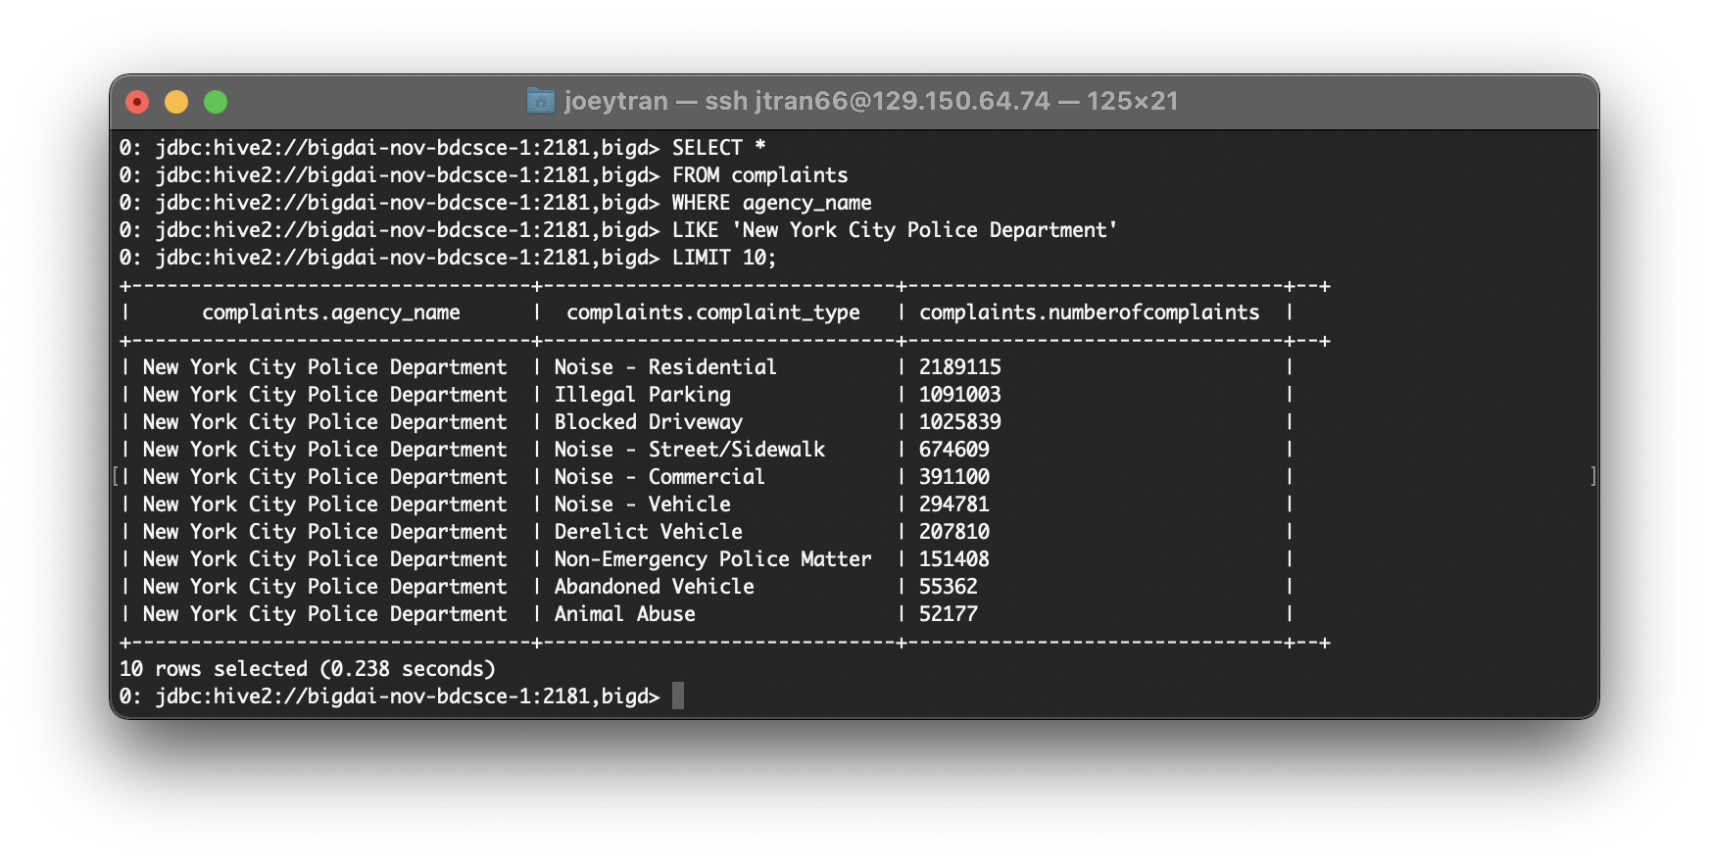

1. This query will build upon the last and find the number of complaints and complaint types that the New York City Police Department handled.

SELECT complaint_type, numberofcomplaints

FROM complaints

WHERE agency_name

LIKE 'New York City Police Department'

LIMIT 10;

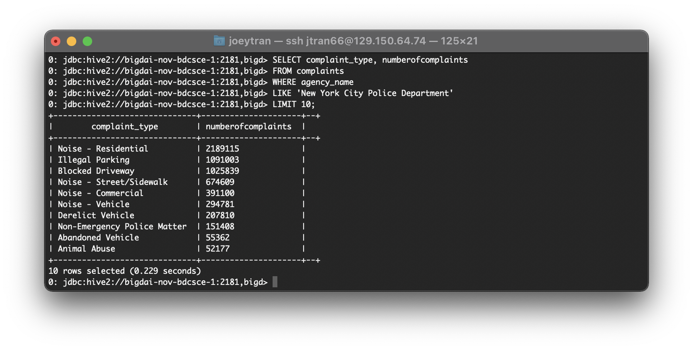

1. We can run the following query to see which agency handed the most complaints.

SELECT agency_name, COUNT(agency_name) AS complaints_handled

FROM complaints

GROUP BY agency_name

ORDER BY complaints_handled DESC

LIMIT 10;

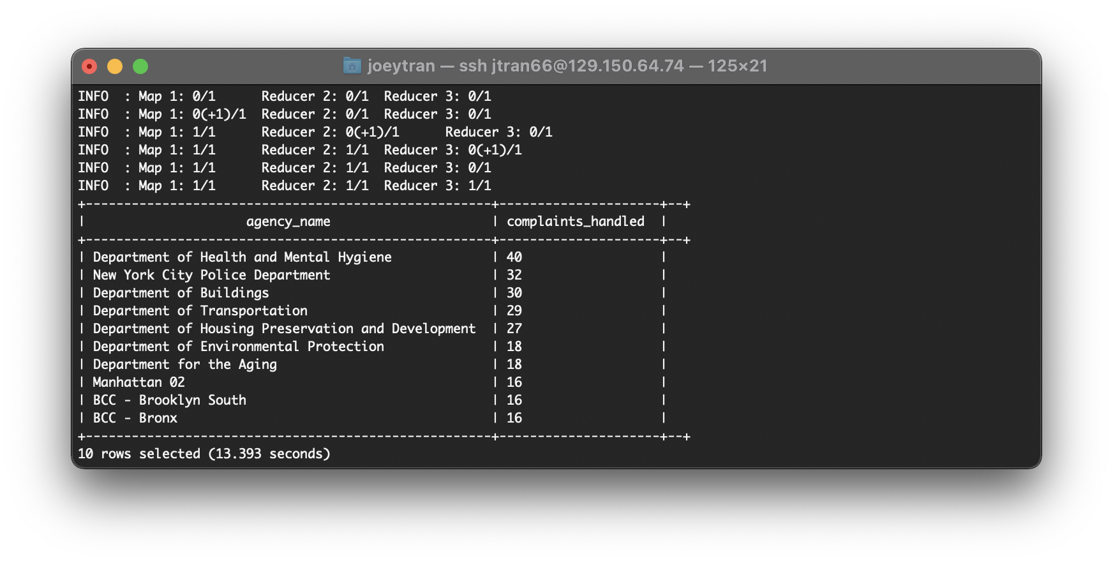

Step 4: Visualization

This step involves importing our dataset into Tableau and analyzing our data through multiple visualizations .

1. At your PC with git bash, xterminal, or pscp.exe, you can remotely download the output file “311_Service_Requests_from_2010_to_Present.csv” to your PC to visualize it using Tableau. NOTE: the following code has “.” at the end.

scp [your_username]@129.150.64.74:/dev/shm/311_Service_Requests_from_2010_to_Present.csv .

1. Open your tableau on your local computer. Select Text File to open your 311_Service_Requests_from_2010_to_Present.csv.

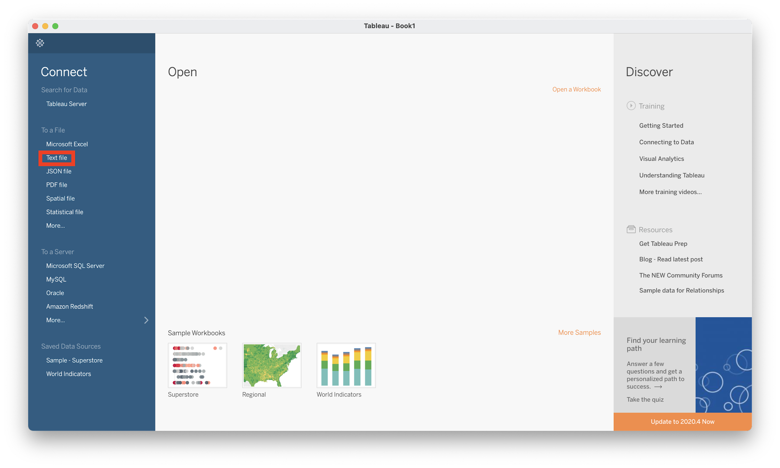

1. Select sheet 1 to start working on our visualization.

In the tableau viewer drag and drop *agency* to the *columns* section and then *Count* to the *rows* section. Then make the marks set for count size and color by dragging the count to the appropriate mark icon. Drag and drop *agency, complaint type* and *agency name* into the labels icon

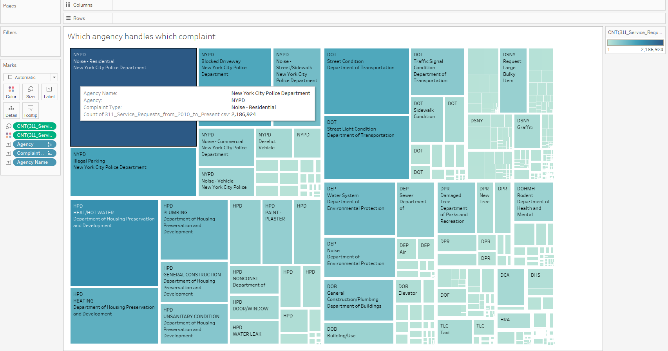

1. Make a new worksheet at the bottom of the tableau viewer. Assign the *Longitude* to the *columns* section and then the *latitude* to the *rows* section. Then import your marks on the map by dragging and dropping *count to color*, *Zip to detail* and *Borough to detail*. You should be able to get a heat map resembling the one below.

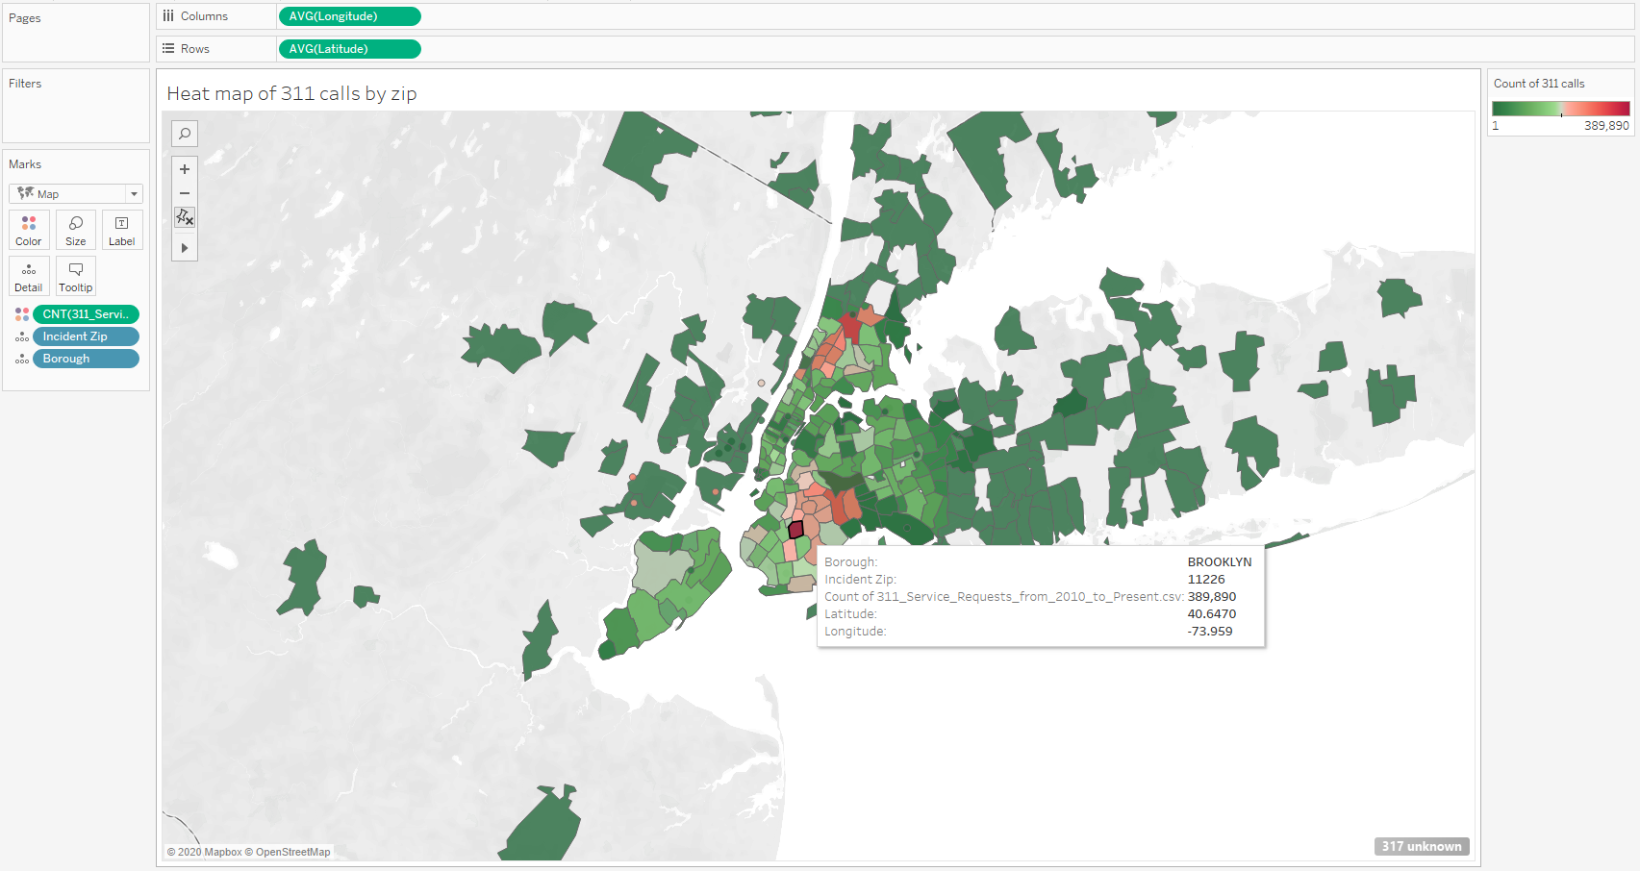

1. On another worksheet simply Drag and drop the *complaint* type into the *Rows* section and the *Count* into the *Columns* section. Then Filter the *complaint* type to a *descending* order. This can be done by clicking the *descending* icon located in the toolbar right below the “window” tab.

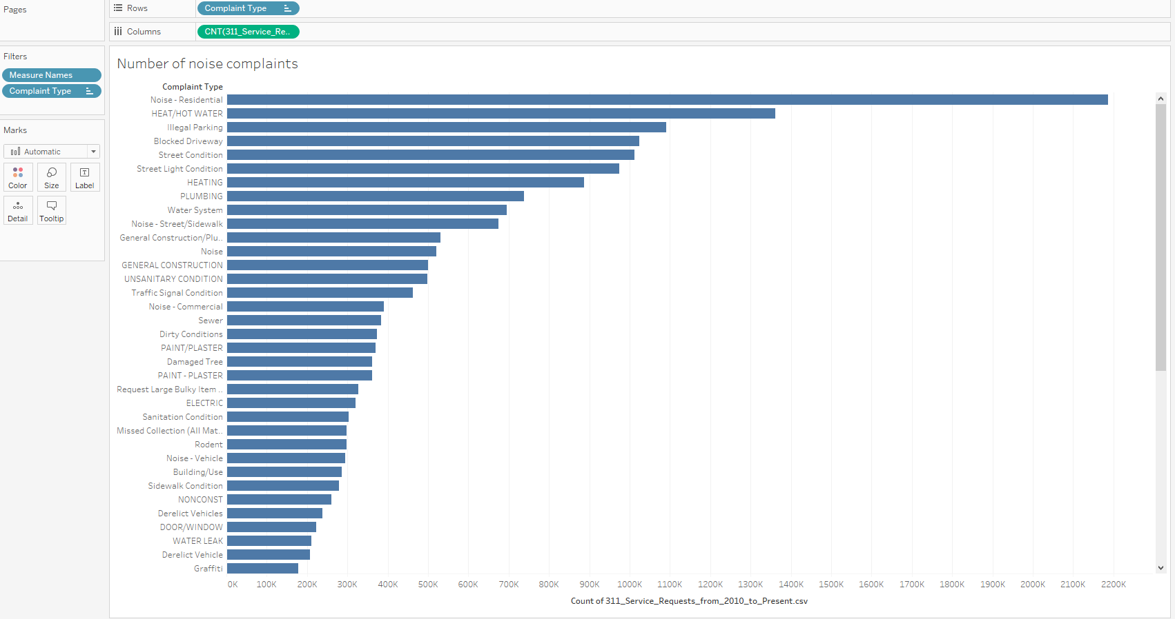

References

1. <https://data.cityofnewyork.us/Social-Services/311-Service-Requests-from-2010-to-Present/erm2-nwe9>